**Module-3: Docker – I Assignment – 1**

You have been asked to:   
● Pull ubuntu container   
● Run this container, and map port 80 on the local  
 ● Install apache2 on this container

● Check if you are able to access the apache page on your browser

Steps Done :

Installed Docker in Ubuntu machine



Pulled Ubuntu container via command docker pull and ran the container

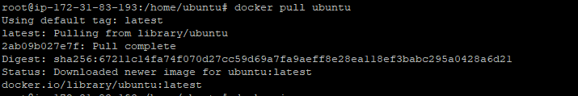

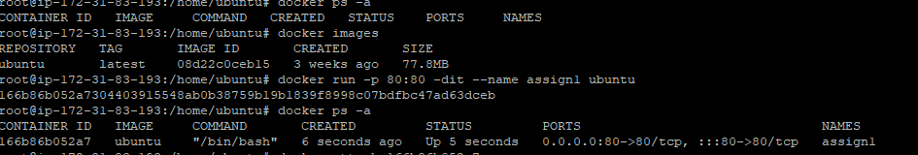

Installing apache 2 on the created container

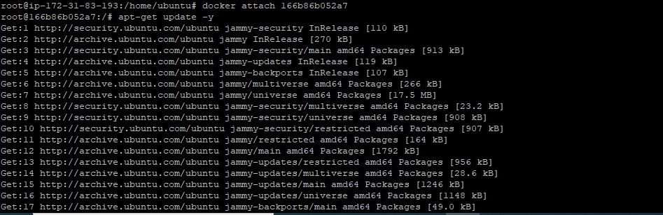

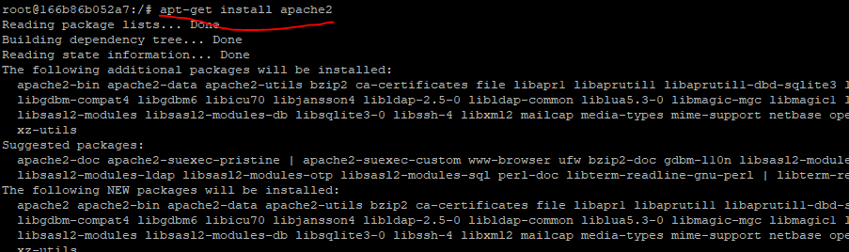

Service started on webpage created

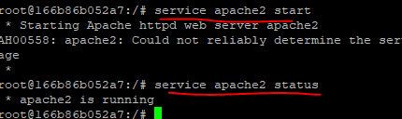

Webpage is working fine as per the tasklist   
